KWA High Street Grants: Information & Application Form

GRANT INFORMATION
This grant has been awarded to Knowle West Alliance by RCKa Architects, working with Bristol City Council, as part of their social value investment relating to the UK Government funded regeneration programme at Filwood Broadway, via Ministry of Housing, Communities and Local Government’s former Levelling Up Fund. RCKa were appointed by the Council to bring forward a planning application to re-build housing and shops at 4-16 Filwood Broadway.
Knowle West Alliance Small Grants fund usually operates a one-grant-per-financial year policy; however, given the exceptional nature of this grant, and the larger pot sizes available, we have agreed an exception to that rule. Therefore, if you have already had a Small Grant since April 2024, you can ALSO apply to this specific grant fund.
Primary aim for this funding:
Projects that increase community activity/footfall on the high streets* within the Knowle West Regeneration Framework area (see map below)
*We are defining high streets as those where there are already shops and businesses open to the public eg. Filwood Broadway, Melvin Square, Jarmans
Projects should also meet at least one of our general Grant criteria listed on the application form below.
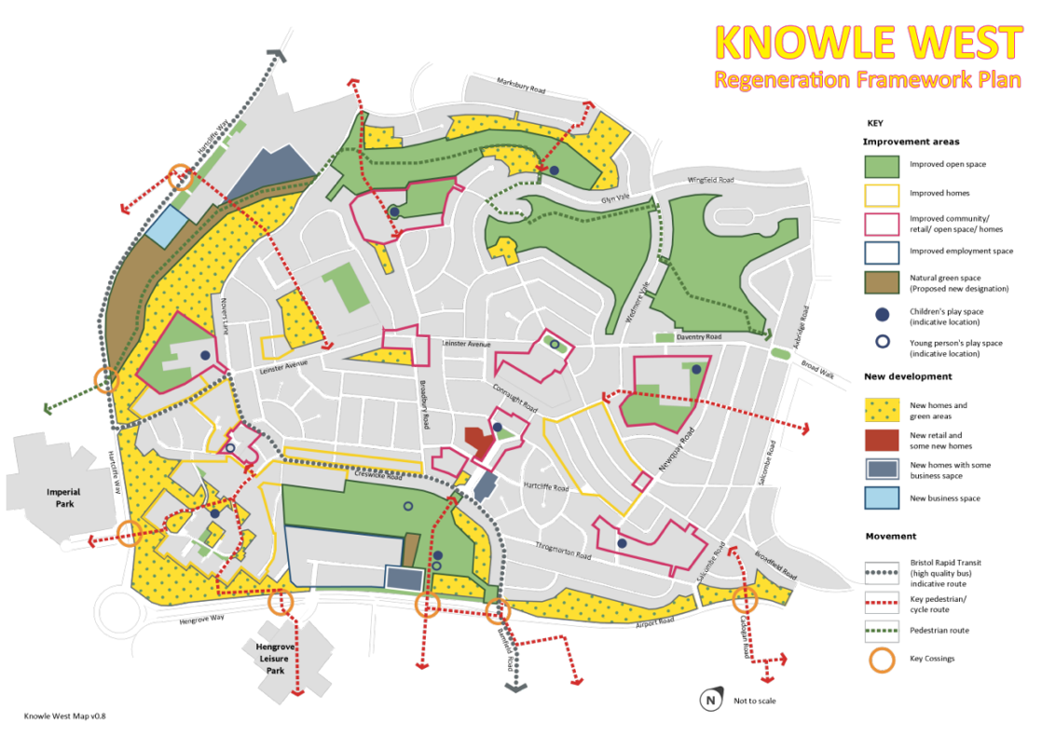
How we are proposing to work: Knowle West Alliance recognises that there are a wide variety of groups, organisations and businesses already present on ‘high streets’ in Knowle West. We are following a network approach and distributing this grant locally – we want to enhance and promote what already exists and give others the opportunity to try something new.
How do you get involved? As a Knowle West-based individual/organisation/group/business/school, you’ll complete the simple application form below detailing your idea.
You can apply for up to £250 if you are an individual or community group, or up to £1000 if you are an organisation, constituted group, business/social enterprise or school. We will reserve the right to part-fund projects where appropriate in the event that we are over-subscribed.
Projects must be to extend activity or increase footfall on ‘high streets’ within the Knowle West Regeneration Framework area between April and December 2025. Unlike our usual KWA Small Grants, we are happy to support business activity that meets the aim of this funding.
The money you get should cover the whole cost of your project; alternatively, you can look for match funding (money from another source) if your project will cost more than the amount of the Knowle West Alliance Grant, but this must not hold up delivery (to be completed by beginning of December 2025).
What happens next? After you’ve put in your application (by 28th March 2025), our Grants Panel will decide if your project meets the grant criteria. If we are unsure, we may ask for more information before making a decision. If your application is successful, we will let you know week commencing 7th April 2025. We will then ask for confirmed details of the project.
How do you get the grant? If you are awarded a KWA Small Grant, you will be sent information about how to claim the funding; it can either be through production of receipts/invoices or via bank transfer to a community group/organisation/business/school bank account with two signatories. This could also be via a suitable third-party bank account with their permission. If awarded a smaller Grant and you do not have a suitable bank account or are unable to make purchases up front, we may be able to buy items for your project on your behalf. You must keep all itemised receipts/records of spend. If you are match-funding your project, you will need to have this funding in place before we will release the grant to you.
Reporting to the funder: Evidence of how your project has worked and the difference it has made should be gathered and shared with Knowle West Alliance in a timely way. This will need to include the increase in the number of people accessing your venue/business/group/activity over the time of the project and should also include photos, messages from those impacted by it, videos and/or news stories etc. These may be shared through our public communication channels so please only provide evidence that you are happy for us to share. By sending this to us, you are giving permission for us to use this to promote local community activity and the KWA Small Grants across our communication platforms. You may also be required to take part in a video to be shared online.
Reporting deadlines: Please note that you will be required to provide feedback and evidence that your project has happened by 12th December 2025. You will be sent a short grant feedback form which you can complete, or someone from KWA can arrange to talk to you about how your project went. We are keen to support this to be straightforward and not take up too much of your time.

Any questions, please contact: info@kwalliance.co.uk
Thank you in advance for taking the time to plan a community project/activity and to make this application.
Best wishes
KWA Team
Application Form
Individual/organisation/group/business name:
Contact name:
Address: | Postcode:
Email: | Phone number:
Project name (eg. local history exhibition):
- What is your project idea? ie. What do you plan to do?

- Describe how this project extends community activity/enhances what you offer/increases footfall and engagement on the ‘high streets’ within the Knowle West Regeneration Framework.

- How many people will be involved? Who will it benefit?

- What will the outcome/impact be ie. what difference will it make?

Which additional criteria does your project meet? (Please tick at least one box)
☐ Making a safer place | ☐ Making a greener place | ☐ Making an active place
☐ Making a friendlier place | ☐ Making a cleaner place | ☐ Making a healthier place

Please indicate which grant you’re applying for (please tick one box only):  - Up to £250 (for projects run by individuals/community groups)  - Up to £1000 (for projects run by established groups/organisations/businesses) | ☐  ☐
How much money will your project cost? | £
How much money are you applying for? | £
Do you have match funding? (ie. money from another source)  If so, how much? (NB. The total cost of the project must be covered.) | Yes / No / NA  £
How will this money be spent? (Please give a breakdown of estimated costs)

Do you have a group/business bank account with at least 2 signatories?  NB. You do not need this to apply for a grant. | Yes / No
Please confirm that you will do the following by ticking the boxes:  - Confirm all project details for publicity purposes by end of April 2025.  - Provide a short video about your project (support can be provided).  - Complete the project by the beginning of December 2025.  - Provide feedback and evidence of how your project has worked when completed and by 12th December 2025 at the latest.  - Add funder logos to any publicity material (these will be provided). | ☐  ☐  ☐  ☐  ☐

How did you find out about the KWA Small Grants? (Please tick one box)
Applied before ☐ KWA Facebook ☐ KWA website ☐ KW Community website ☐
The Knowledge ☐ Flyer/poster ☐ Other social media/website ☐
Which one? (eg. name of Facebook group) __________________________________________________
Word of mouth ☐ Who or which group/org? _______________________________________________
Other ☐ Please state: __________________________________________________________
Please email your completed application form to info@kwalliance.co.uk or drop it in to Knowle West Media Centre on Leinster Avenue.

